# **Project Management Application**

Source code of API, UI available in below path in VM

UI:

C:\ProjectManagementUI

API:

C:\ProjectManagerApi

Both projects configured in Jenkins and hosted in IIS

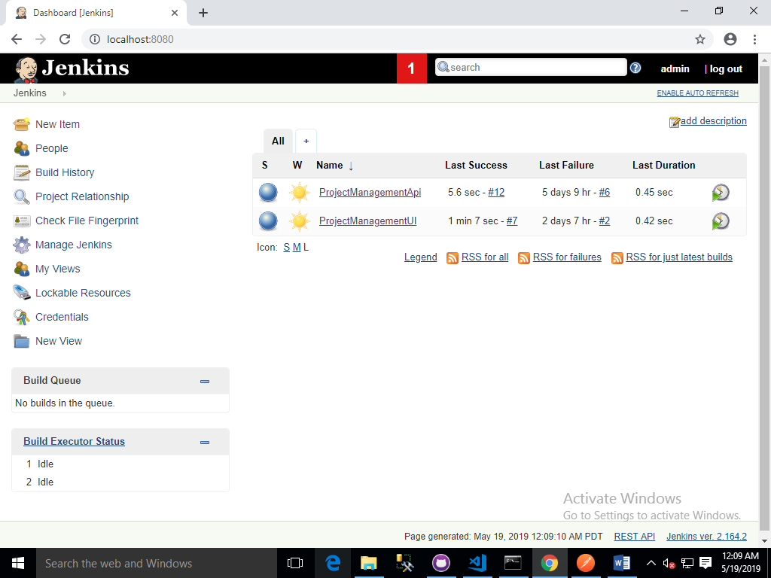

<http://localhost:8080/job/ProjectManagementApi/>

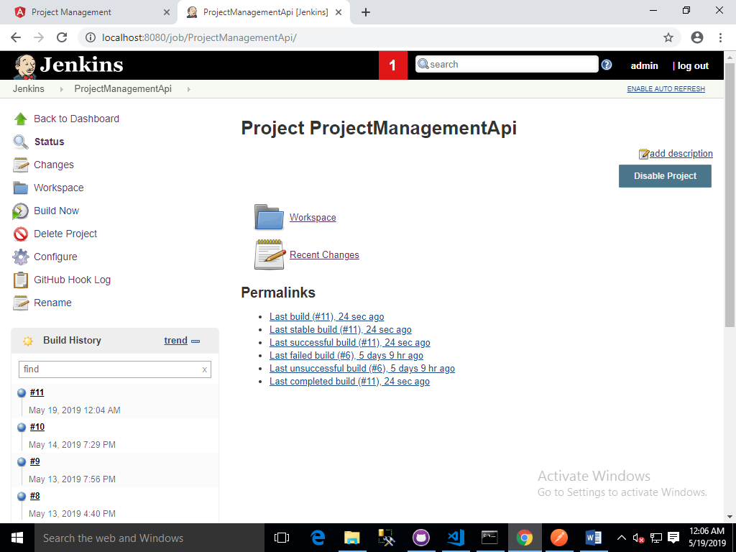

<http://localhost:8080/job/ProjectManagementUI/>

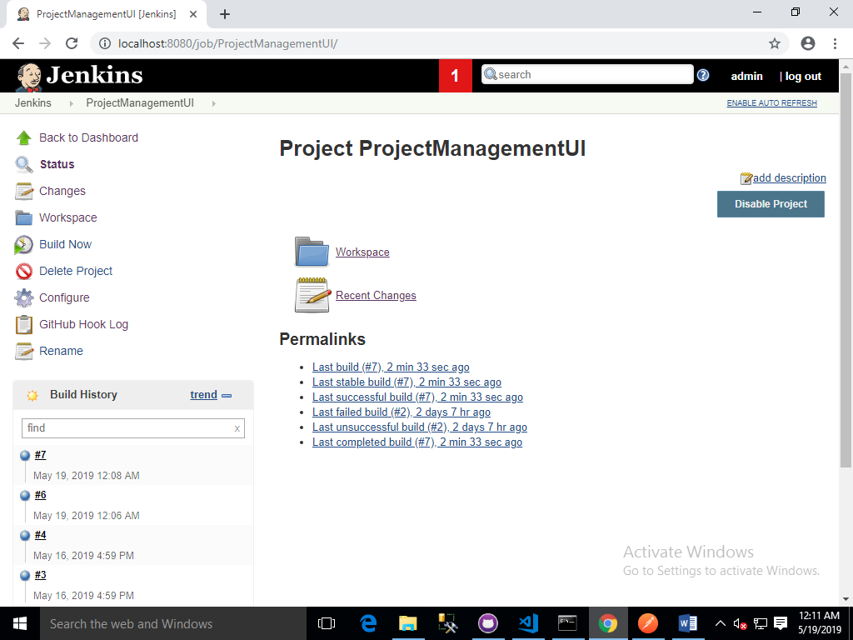

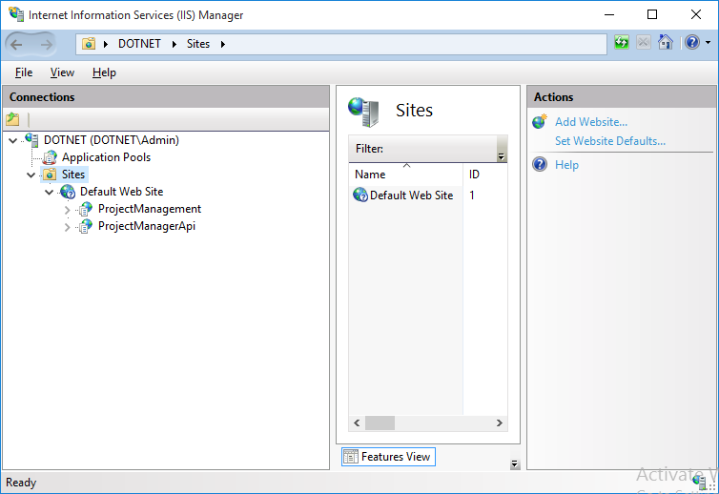

## Project Management API

URL: <http://localhost/ProjectManagerApi>

Routes:

<http://localhost/ProjectManagerApi/api/projects/>

<http://localhost/ProjectManagerApi/api/tasks>

<http://localhost/ProjectManagerApi/api/users>

Instruction to get other routes in this api

|  |  |
| --- | --- |
| **Description** | **Route** |
| To get all projects/tasks/users | //GET: {baseurl}/api/{controller}  **Example**: http://localhost/ProjectManagerApi/api/projects/ |
| To get single project/task/user | //GET: {baseurl}/api/{controller}/id  **Example**: <http://localhost/ProjectManagerApi/api/projects/id> |
| To post project/task/user | //POST: {baseurl}/api/{controller}/  **Example**: http://localhost/ProjectManagerApi/api/projects/ |
| To update project/task/user | //put: {baseurl}/api/{controller}/id  **Example**: <http://localhost/ProjectManagerApi/api/projects/id> |
| To delete project/task/user | //delete: {baseurl}/api/{controller}/id  **Example**: <http://localhost/ProjectManagerApi/api/projects/id> |

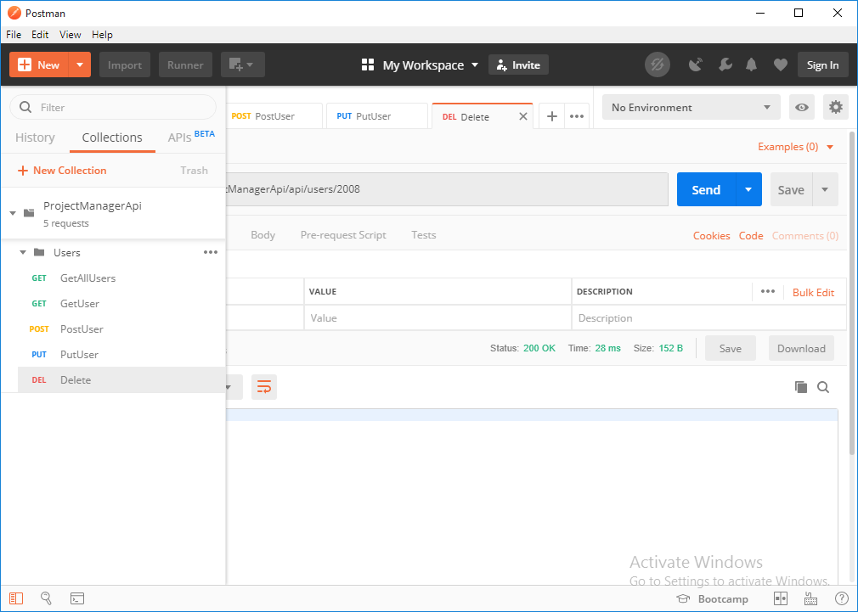

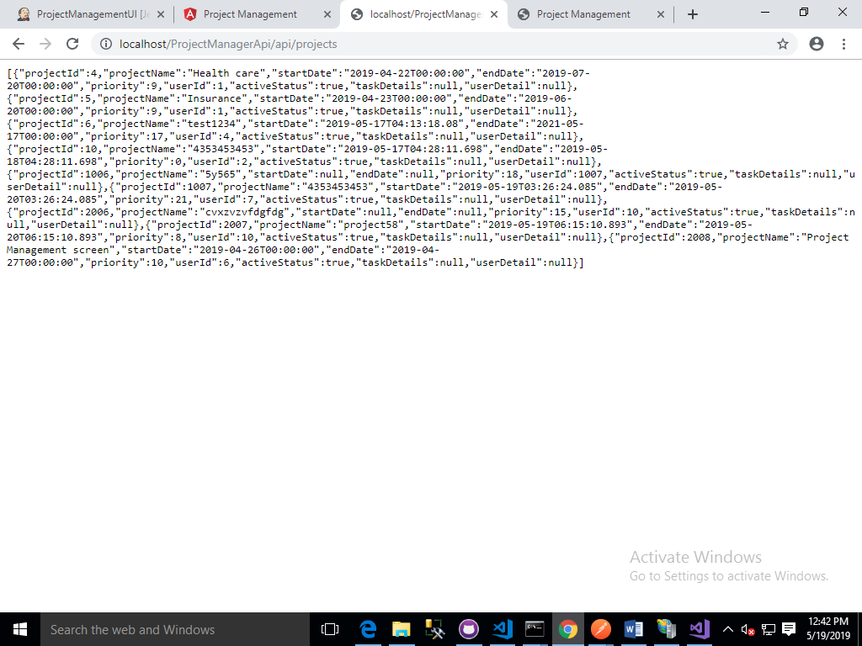

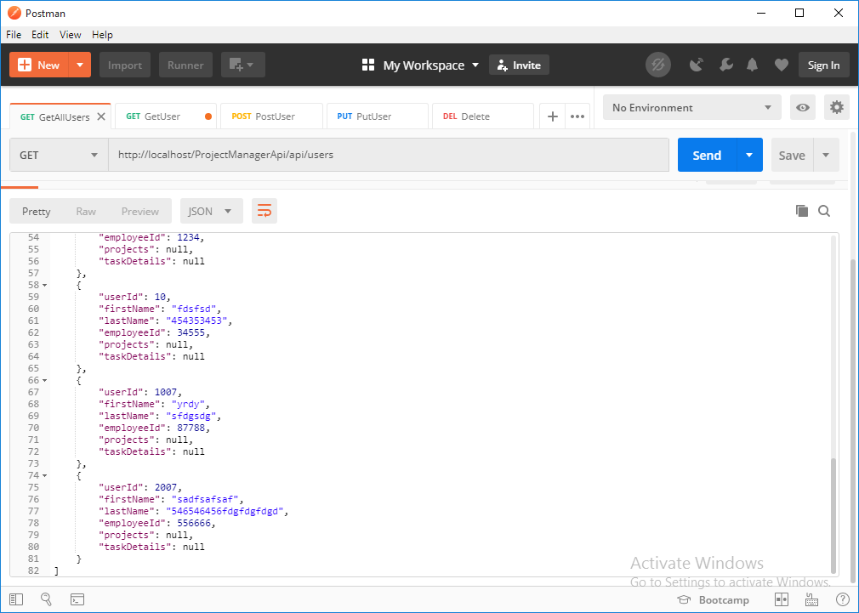

Source Code Solution:-

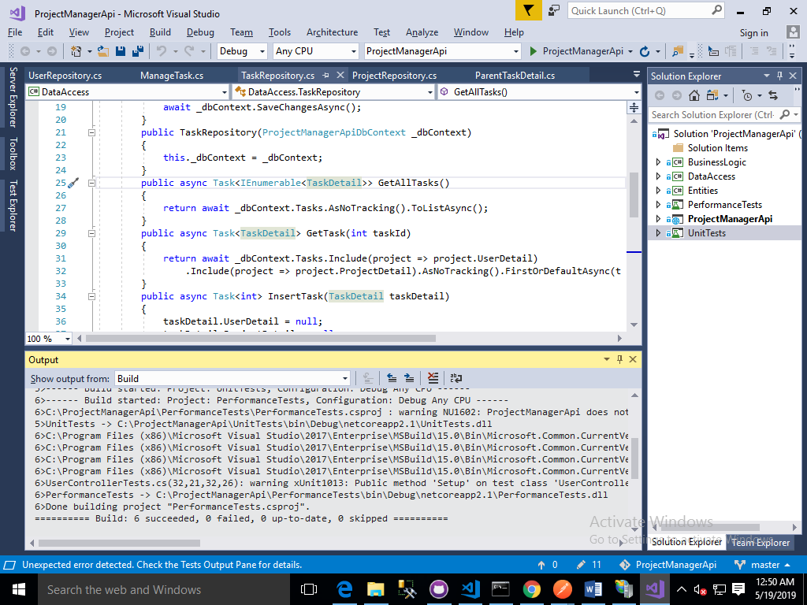

Unit Testing:-

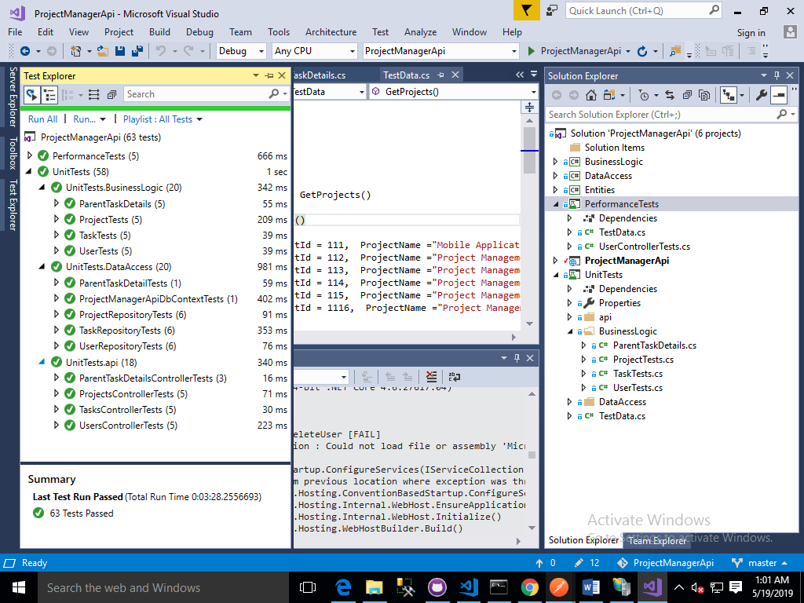

Unit test coverage:-

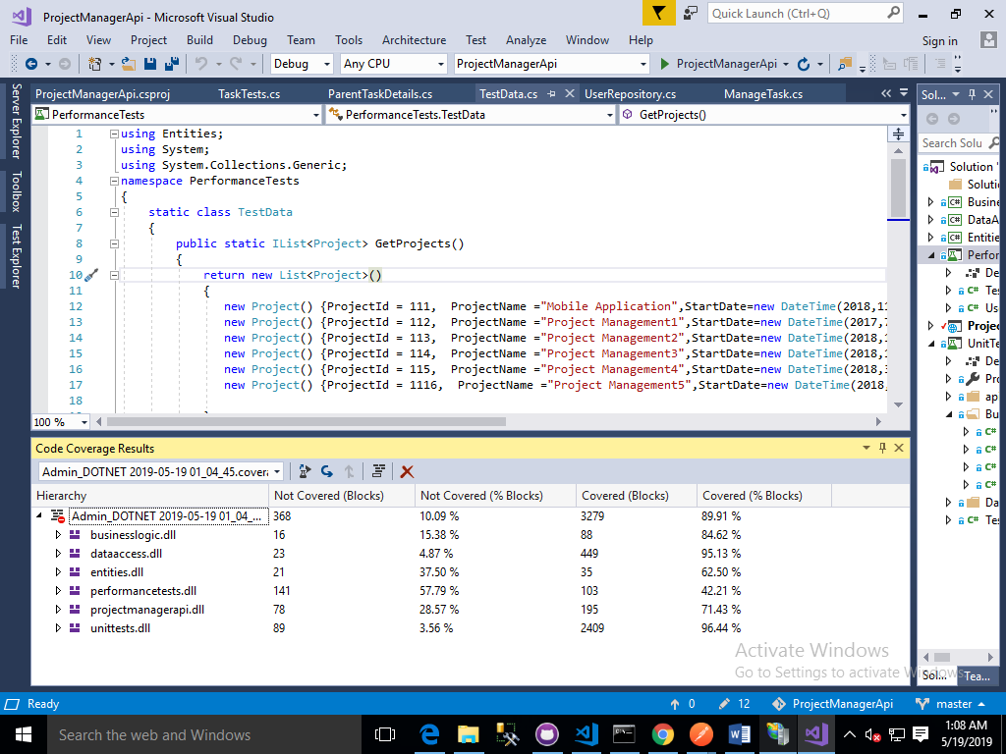

## Project Management UI

URL: <http://localhost/ProjectManagement/>

### Add User

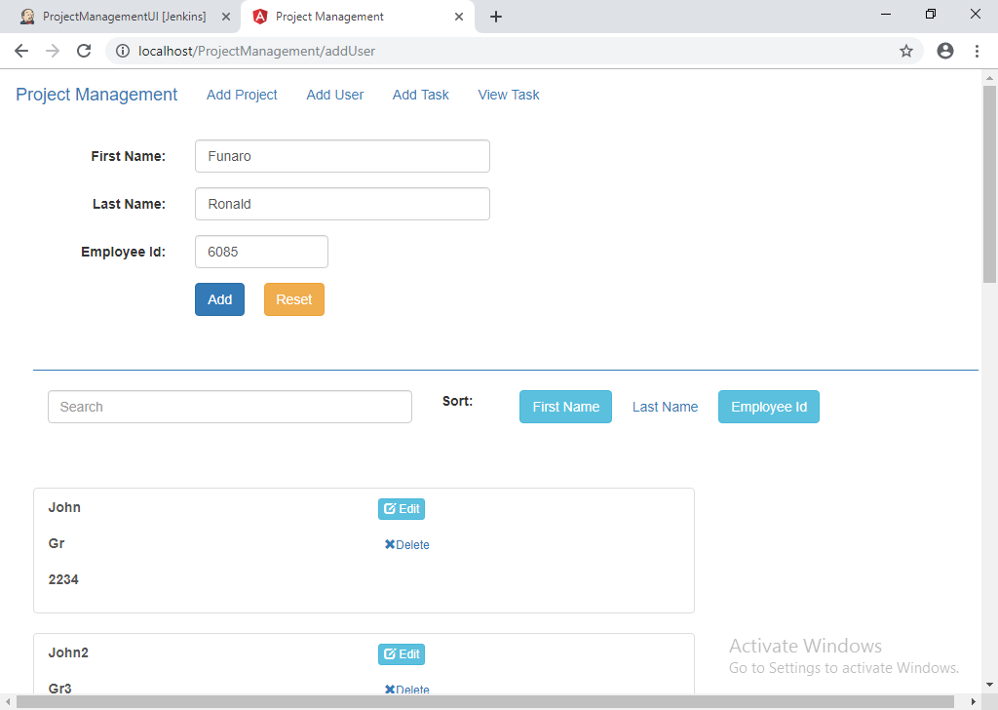

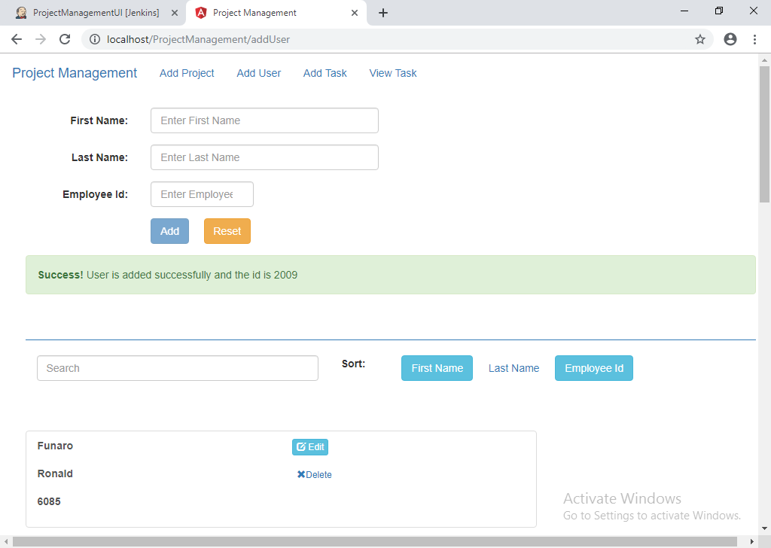

### Update User

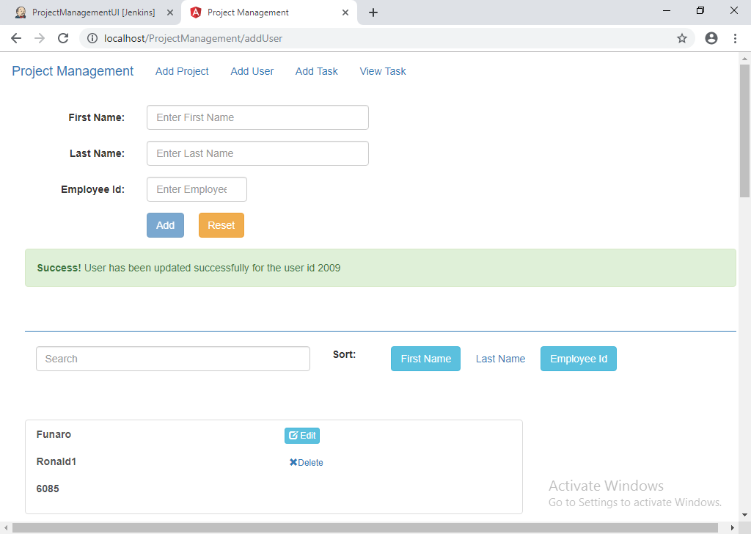

### Add Project:

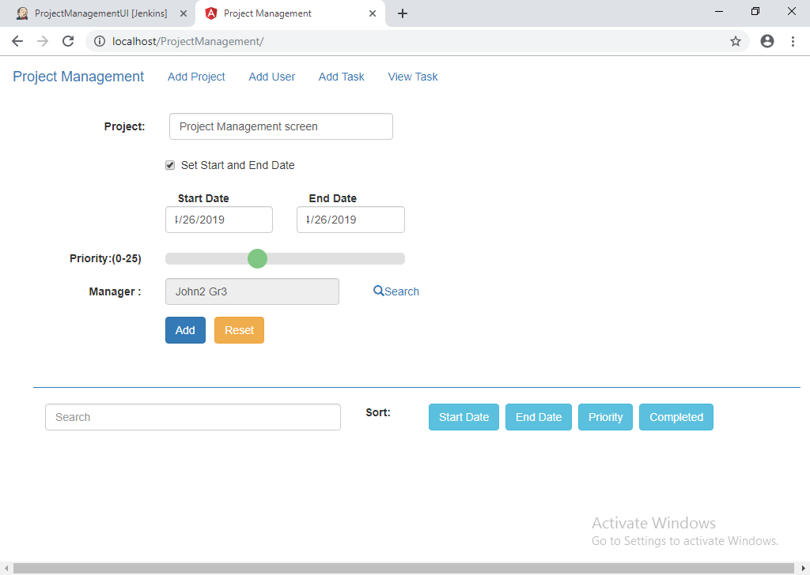

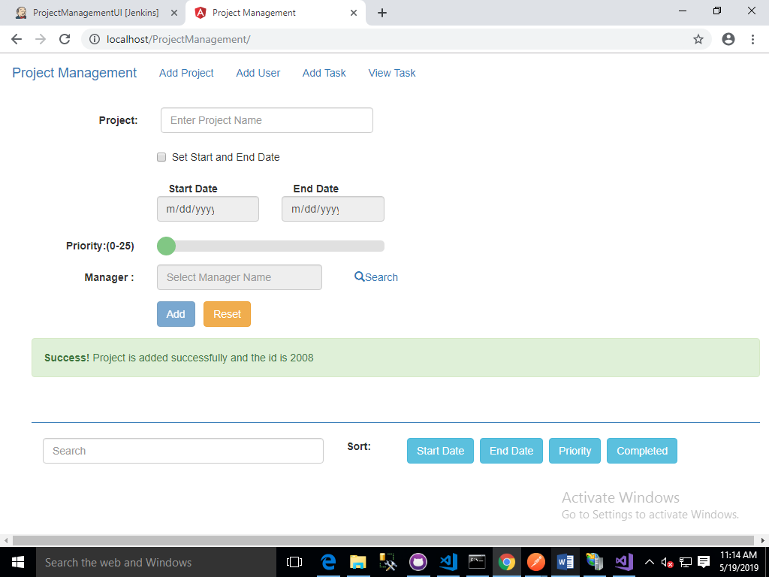

### Add Task

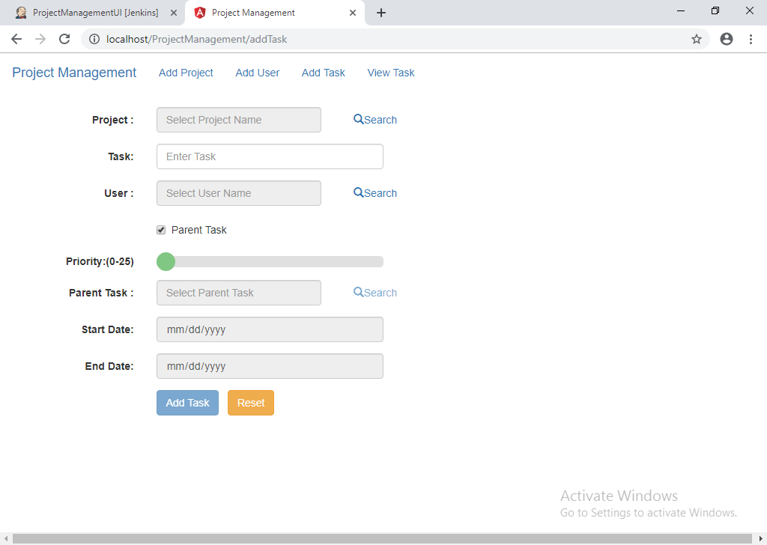

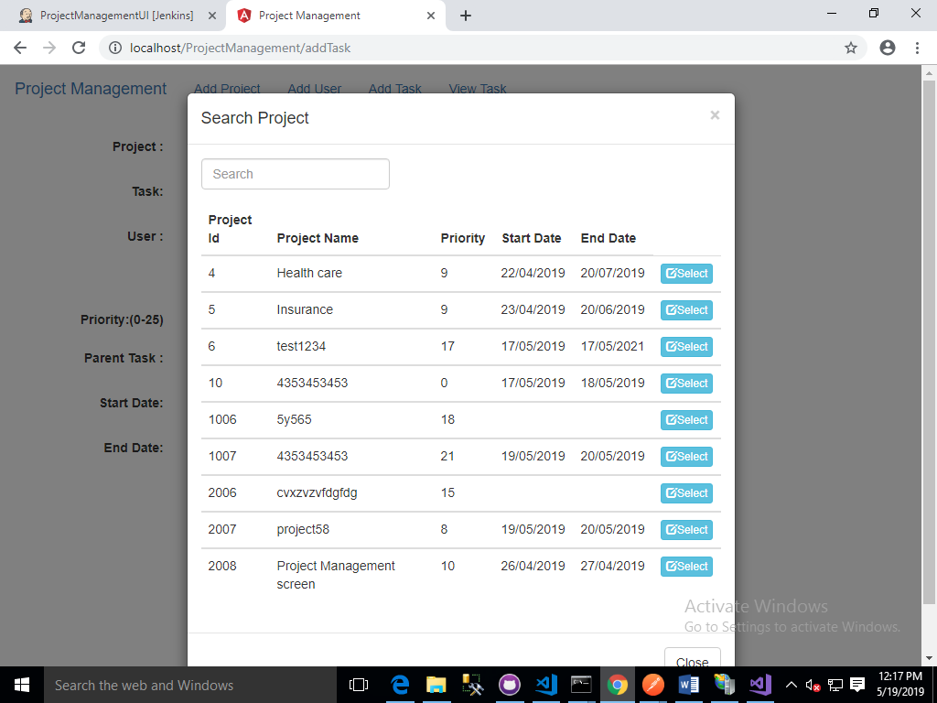

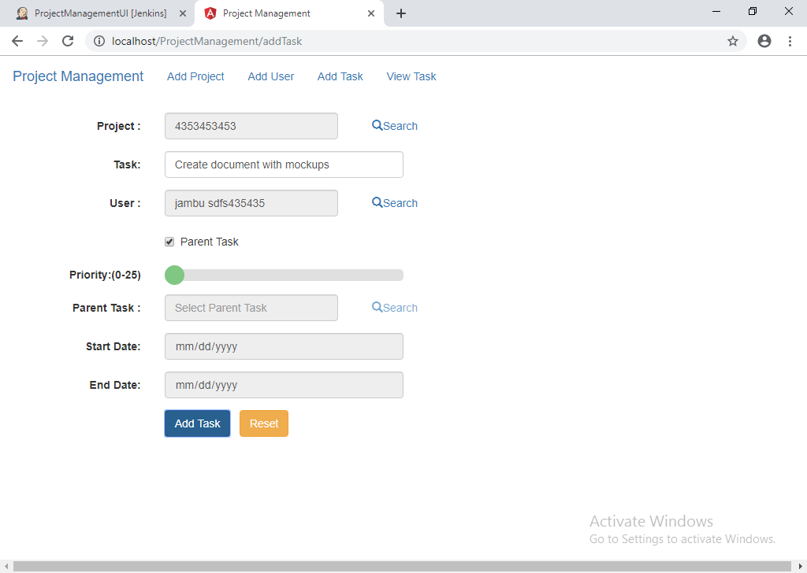

### View Task

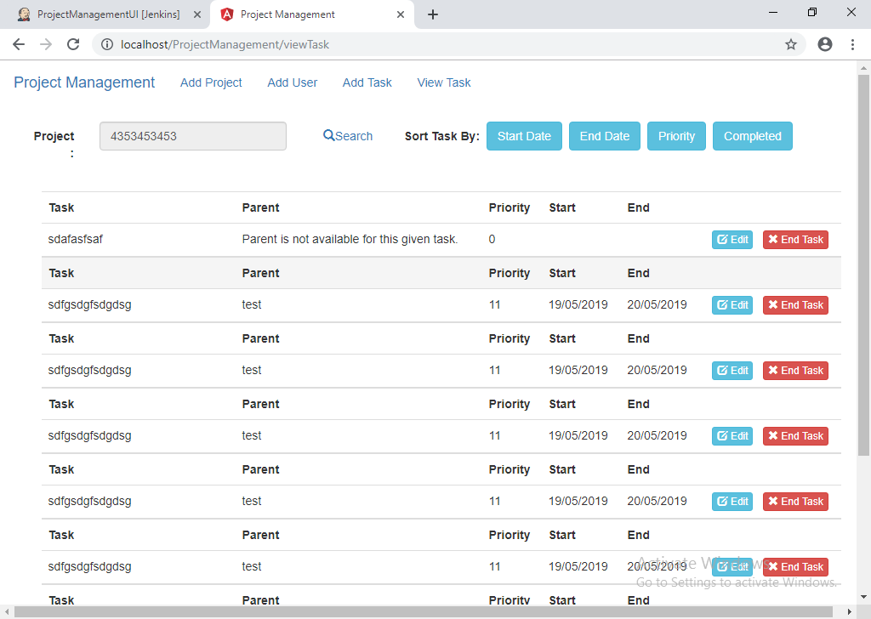

Jasmine tests: 